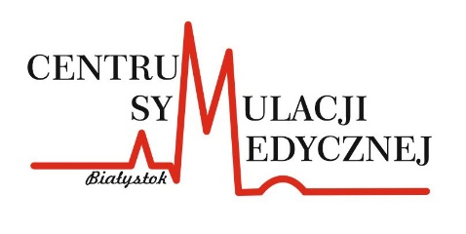
REGULATIONS
Medical Simulation Center of the Medical University of Białystok
Applicable to Students

General Provisions
ᴥ
- The following Regulations of Classes, hereinafter referred to as the 'Regulations,' define the rules for conducting activities at the Medical Simulation Center (hereinafter referred to as the CSM) applicable to students.
- The CSM regulations comply with the regulations of the first-degree studies, second-degree studies, and integrated master's studies at the Medical University of Białystok.
- In addition to the CSM regulations, students are also bound by the didactic regulations of the relevant academic unit displayed on the notice board of the unit and published on the unit's websites.
- Alcohol consumption, the use of tobacco products, and electronic cigarettes are prohibited on the premises of the CSM.
- Beverages and meals are not allowed in the CSM laboratories.
- The student is obliged to familiarize himself/herself with and adhere to occupational health and safety (BHP) and fire safety regulations.
- To ensure student safety during the learning process and constructive debriefing, strict adherence to the confidentiality principle is required regarding the clinical and interpersonal issues discussed during the classes. The principle of "what happened in the simulation room stays in the simulation room" applies.
Provisions regarding classes
ᴥ
- Before the start of classes, all personal belongings must be left in the student locker room.
- The student is responsible for his/her own personal belongings. The CSM staff are not responsible for loss or damage to the aforementioned items.
- During all classes, students must adhere to the prescribed attire, have changed footwear, tied hair, wear a lab coat/scrubs, and have a stethoscope.
- Students not complying with the recommended attire may be asked to leave the class by the assistant or the instructor/technician.
- Quiet and polite behavior is required in the lobby and common areas.
- During classes in the CSM laboratories, students are not allowed to use electronic devices without the instructor's permission (cell phones, laptops, audio equipment, etc.).
- Taking photos, recording sound, and/or filming during seminars and exercises without the instructor's consent is prohibited.
- During CSM classes, students are under the supervision of the academic teachers conducting the classes.
- In the educational laboratories of the CSM, students may be present only in the presence of an academic teacher or simulation instructor/technician.
- Students are not allowed to be in control rooms during classes, except in situations specified in simulation scenarios.
- The rooms are equipped with devices recording image and sound during classes conducted using medical simulation-based methods.
- Personal data in the form of students' and instructors' images and voices are processed during classes for recording purposes to conduct debriefing.
- The processing of images and voices is based on Article 6, letter c of the Regulation (EU) 2016/679 of the European Parliament and of the Council of 27 April 2016 on the protection of natural persons with regard to the processing of personal data and on the free movement of such data, and repealing Directive 95/46/EC (General Data Protection Regulation) - hereinafter referred to as RODO.
- Recordings are deleted after the completion of the classes.
Provisions regarding equipment
ᴥ
- The student is obliged to promptly inform the academic teacher conducting the class about any accidents that occur during educational activities.
- The student is obliged to promptly inform the academic teacher conducting the class and/or the technician about any damage or malfunction of equipment.
- It is prohibited to move simulators without the presence of CSM staff - simulators should not be lifted by their limbs.

