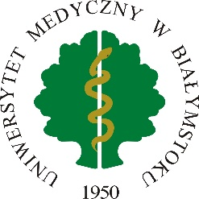 | MEDICAL UNIVERSITY OF BIALYSTOK  ERASMUS+ PROGRAMME  Student / PhD Student / Graduate / Post-doc Traineeships  LETTER OF INTENT | 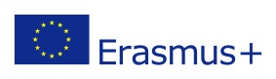
Załącznik nr 3 do Regulaminu Wyjazdów w ramach Programu Erasmus+ wprowadzonego Zarządzeniem Rektora nr

Host institution
Address
Country

Hereby, we confirm our willingness to host Mr. / Ms. ………………….……………………………………,
a Student / PhD Student/Graduate/Post-doc* of MEDICAL UNIVERSITY OF BIALYSTOK for at least
2-month traineeship from …/…/20…… to …/…/20……. within the framework of Erasmus+ Programme.
Short description of the traineeship programme

Person responsible for the traineeship of the above-mentioned person
Name
Position
Address
Postal code, city
Country
E-mail

Date | Signature of authorized person | Stamp of the host Institution
*Delete as appropriate

