Professor Yegor Vassetzky
Prof. Yegor Vassetzky is a leading expert in the fields of molecular biology, epigenetics, and cancer biology.
He currently serves as CNRS Research Director (DRCE) and leads the Chromatin Dynamics and Metabolism in Cancer team within CNRS UMR9018 at the renowned Gustave Roussy Institute in Villejuif (France).
Gustave Roussy is France’s and Europe’s leading cancer centre and is ranked the world’s sixth best oncology hospital by Newsweek. Prof. Vassetzky has been affiliated with the Institute since 2002.
He is also a lecturer at Sorbonne University.
His main research interests include epigenetic regulation, chromatin dynamics, and their role in the development of cancer and genetic diseases. His team’s research focuses, among other areas, on the relationship between chromatin dynamics and metabolism in cancer cells.
Prof. Vassetzky is the author of over 180 scientific publications in renowned international journals, including Cell, Nature Communications, PNAS, Blood, Leukemia, and Nucleic Acids Research. His publications have been cited over 5,300 times, and his H-index is 43. Throughout his career, he has supervised 28 PhD students, 32 Master’s students, and 8 postdoctoral fellows.
He is also the Founder and Scientific Consultant of the biotechnology startup GéneVert, combining his academic work with the practical application of scientific research.
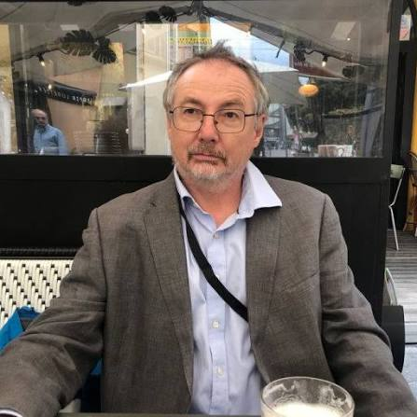
https://orcid.org/0000-0003-3101-7043

